IT2035C Networking Infrastructure Management

Configuring DHCP, DNS, and HTTP Lab 3 Submission Form

Complete the DHCP, DNS, and HTTP Lab 3 and insert the following screenshots. Ensure all screenshots are viewable.
- Network Diagram. Includes the router, switches, a server, and PCs. All statically assigned addresses are annotated. Student's name, section number, and lab number are shown.
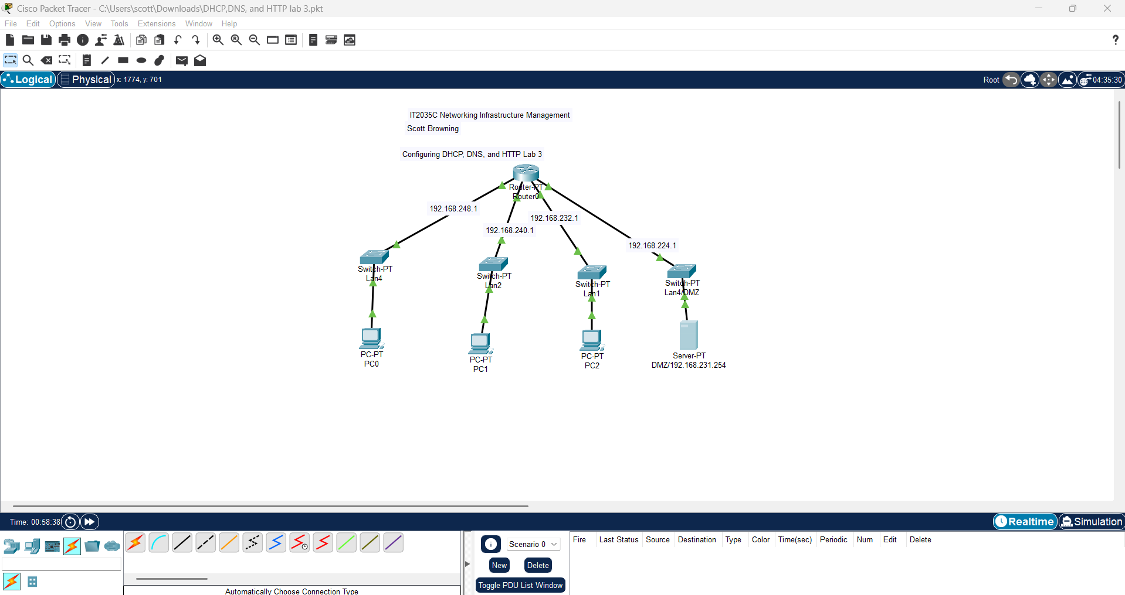

- DCHP. Configuration of the DHCP pools displaying the correct range of IP addressing, default gateway, and subnet mask for each subnet. Ensure the entire pools is displayed.
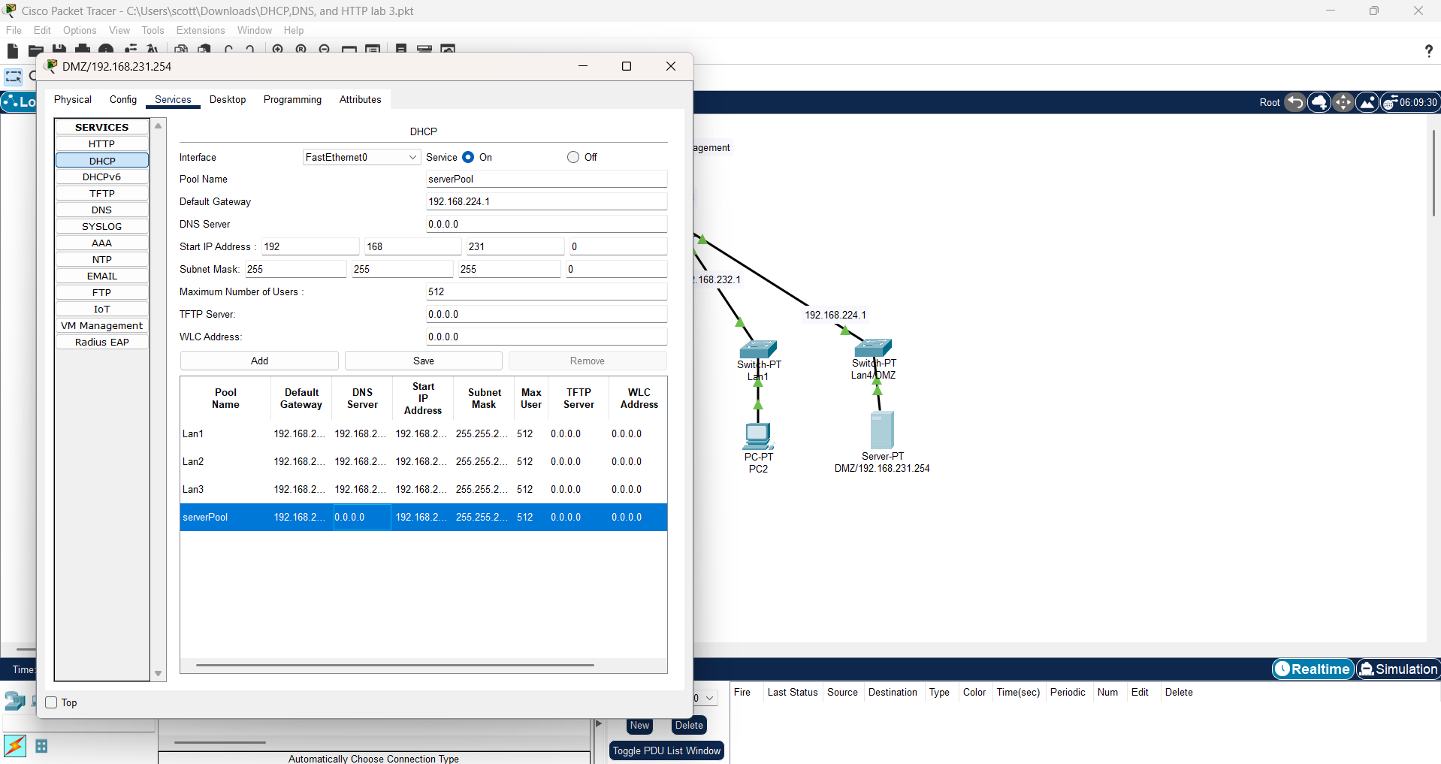

- Web Page. In one of the PCs, type the URL in the browser and submit a screenshot of the resulting web page.
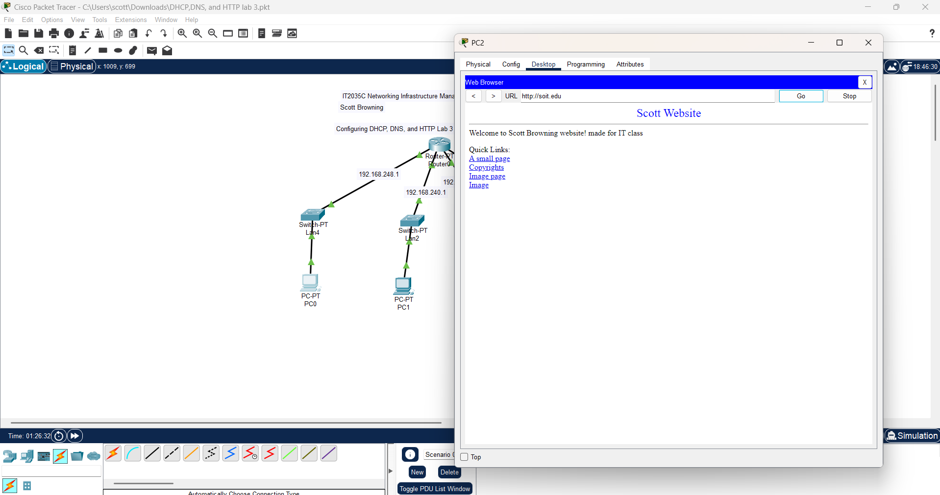

- PC Configuration. Configuration on one of the PCs showing a valid address, default gateway, subnet mask, and DNS server address assigned through DHCP.
